

YEAR 12 MATHEMATICS METHODS Test 2 2016
Exponential and Trigonometric Functions

NAME: _________________________________________ Date: Tuesday 10th May

TEACHER: ____________________________

Non-calculator section: | 33 minutes | 33 marks
Calculator section: | 17 minutes | 17 marks
OVERALL: | 50 minutes | 50 marks

INSTRUCTIONS:
Show FULL working Answer all questions on this test paper
Questions or parts of questions worth more than two marks require working to be shown to receive full marks.
Allowed: Maths Methods WACE formula sheets

TRIG FORMULA: $\cos{2θ=}\cos^{2}{θ-\sin^{2}{θ}}$ $\sin{2θ=}2\sin{θ\cos{θ}}$

$\lim_{h→0}{{\left(\frac{1-\cos{h}}{h}\right)}^{}=0}$ $\lim_{h→0}(\frac{\sin{h}}{h})=1$

Q1 (5 marks)
Determine the equation of the tangent to the curve at the point ().

Q2 (3 + 3 + 3 + 3 = 12 marks)
Determine $\frac{dy}{dx}$ for each of the following simplifying answers where possible.

(a) $y= e^{x^{2}-1}+2\cos{(2x-1)+e^{3}}$

(b) ${y=sin}^{3}{5x}$

(c) $y=\frac{\cos{x}}{e^{x}}$

(d) $y=e^{(1-x)}\sin{2x}$

Q3 (4 + 2 + 1 = 7 marks)
Evaluate the following.

(a) $\int_{0}^{\frac{π}{3}}{(\cos{\frac{x}{2}}-sin{x}}).dx$

(b) $\frac{d}{dx}(\int_{3}^{x^{2}}{e^{(\sqrt{t}-1)}}.dt)$ when $x=2$

(c) $\lim_{h→0}{\frac{\sin{h}}{2h}}$

Q4 (2 + 2 + 3 + 2 = 9 marks)
Evaluate the following integrals.

(a) $\int{{(e}^{x}}+\cos{x+\sin{x).dx}}$

(b) $\int{\frac{2}{e^{3x}}}.dx$

(c) $\int{\frac{\sin{x\cos^{3}{x}}}{2}}.dx$

(d) $\int{4\sin{x\cos{x.dx}}}$

END OF SECTION 1


YEAR 12 MATHEMATICS METHODS Test 2 2016
Exponential and Trigonometric Functions

NAME: _________________________________________ Date: Tuesday 10th May

TEACHER: ____________________________

Non-calculator section: | 33 minutes | 33 marks
Calculator section: | 17 minutes | 17 marks
OVERALL: | 50 minutes | 50 marks

INSTRUCTIONS:
Show FULL working Answer all questions on this test paper
Questions or parts of questions worth more than two marks require working to be shown to receive full marks.
Allowed: Maths Methods WACE formula sheets, 3 calculators, 1 A4 page of notes

Q5 (4 marks)
A curve passes through the point ($\frac{π}{2}, π-2)$ and has a gradient function given by $\frac{dy}{dx}=1-2\cos{x}$ . Determine the equation of the original curve.

Q6 (1 + 2 + 1 + 2 + 4 = 10 marks)
The mass of a drug remaining in the bloodstream of a patient is changing according to the rule , where is the mass of drug remaining hours after the initial dose of 60 milligrams was administered.

(a) Circle the response below that best describes the type of relationship between
and .

EXPONENTIAL GROWTH EXPONENTIAL DECAY

(b) Write down an equation for in terms of .

(c) Determine the mass of drug remaining in the bloodstream after one day.

(d) Determine, to the nearest hour, the time taken for less than one percent of the
initial dose to remain in the bloodstream of the patient.

(e) At what rate is the mass of the drug in the bloodstream changing

(i) after 12 hours?

(ii) when 25mg of the drug remains?

Q7 (3 marks)
A section of the graph of the function $y=0.5-\sin{x}$ is shown below. Calculate the enclosed area between the function stated and the x axis as shown in the diagram.

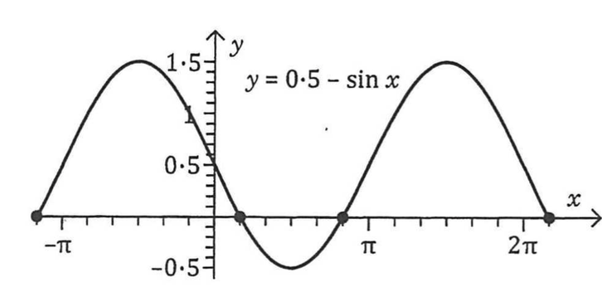

END OF SECTION 2

